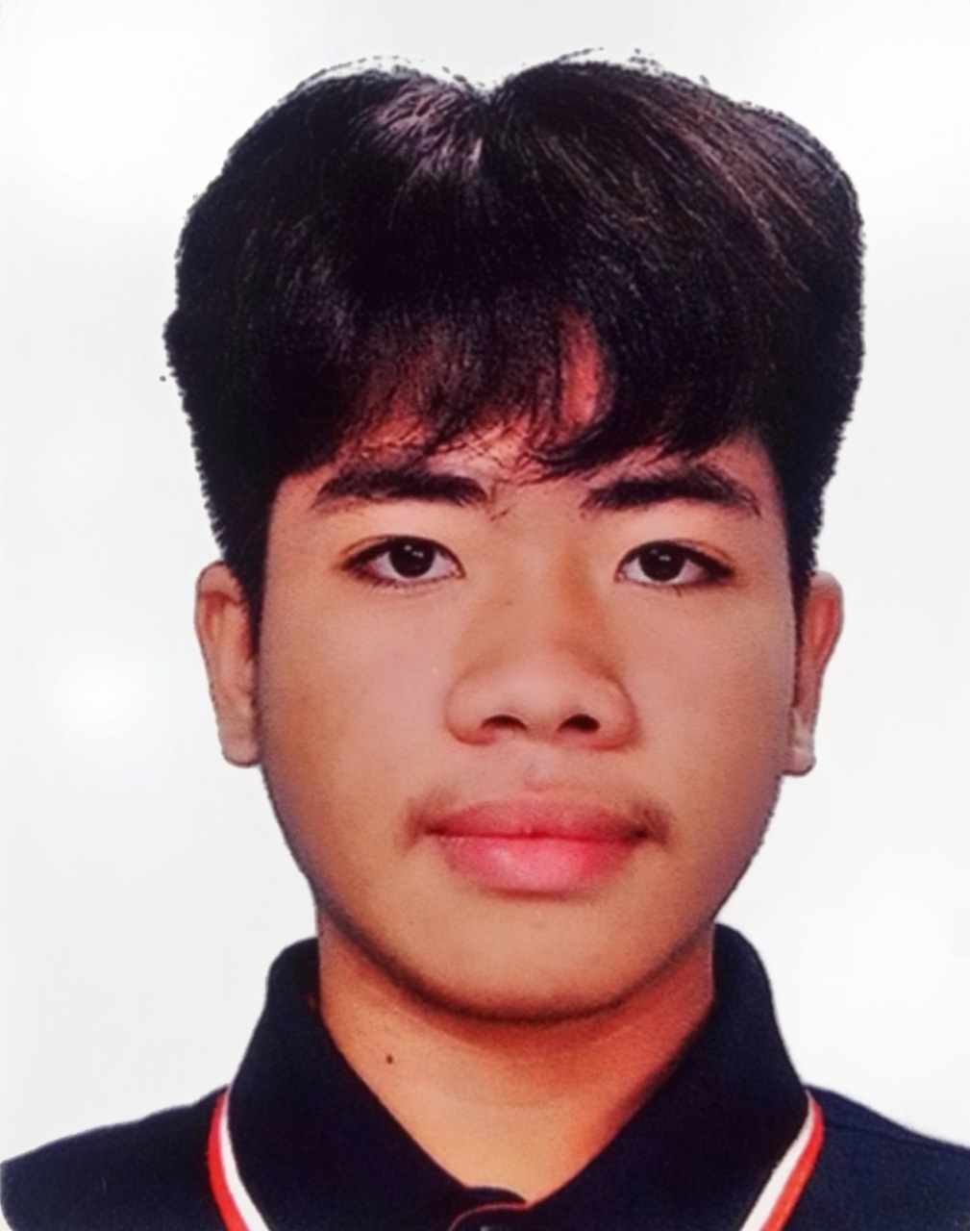**REDJAN PHIL S. VISITACION**

Purok – 4 Mobod, Oroquieta City, Misamis Occidental

Contact No: 09534181760

Tiktok Acc : <https://www.tiktok.com/@rpsv_codes>

**PERSONAL DATA**

**Date of Birth:** July 9, 2005 **Citizenship:** Filipino

**Birth Place:** Purok – 4 Mobod **Civil Status:** Single

**Age:** 18 **Height:** 5’7

**Sex:** Male **Weight:** 64 kg

**EDUCATIONAL ATTAINMENT**

**COLLEGE** University of Science and Technology of Southern Philippines

P – 2 Mobod, Oroquieta City

**SENIOR HIGH SCHOOL** Deor & Dune Academe School of Technology, Inc. 2020 – 2023

P – 1 Mobod, Oroquieta City

**JUNIOR HIGH SCHOOL** Mobod Integrated School. 2016 – 2020

P – 2 Mobod, Oroquieta City

**ELEMENTARY LEVEL** Mobod Integrated School. 2010 – 2016

P – 2 Mobod, Oroquieta City

**SKILLS AND QUALIFICATIONS**

* CSS NCII Holder
* MS Office. Word, Excel, Powerpoint, Access
* Computer Network
* Editing
* Programming

**TRAINING AND WORK EXPERIENCE**

* On-the-job of Provincial Agriculture’s Office Under the program of (SPES).
* Accomplishing the assessment training of Computer System Servicing NCII.
* Job experience at Micron Electronics being technician